CLASS VI UNIT 14 PRACTICAL GEOMETRY
GIST of the LESSON
- CONSTRUCTION OF A CIRCLE .
Centre of a circle ,Radius of a circle .Diameter of a circle .
- CONSTRUCTION OF A LINE SEGMENT .
A line segment is bounded by two end points .
Accurate measurement of given length using ruler .
Constructing a copy of a given line segment .
- PERPENDICULARS .
TWO lines are said be perpendicular if they intersect such that the angles formed between them are right angles .
- ANGLES
Constructing an angle of a given measure .
Angles of special measure .
Activity
Do you always need protractor to construct angles ?
Angle of 60⁰
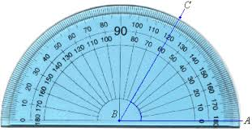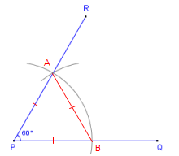
Using Protractor Using ruler and Compass
Angle of 60⁰
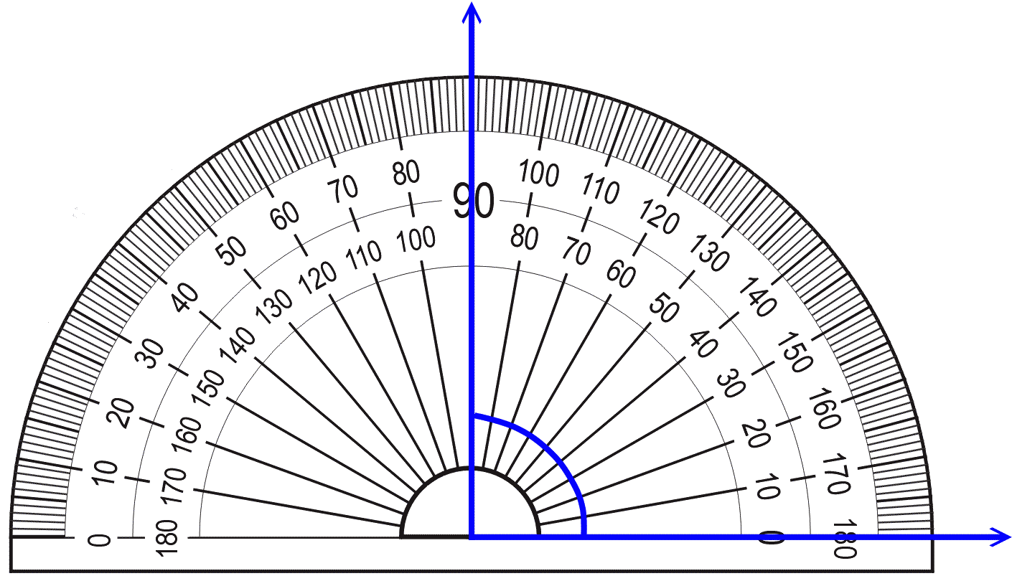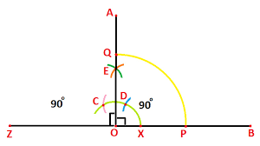
Using Protractor Using ruler and Compasses
Similarly other special angles can be constructed using both the methods and thus simultaneously verified.

LEVEL 1
Q 1 Draw a circle of radius 4 cm .
Q 2 With the same centre O .draw two circles of radii 6 cm and 3.5 cm.
Q 3 Draw a line segment of length 6.5 cm using a ruler .

LEVEL 2
Q 1 Construct a line segment of length 7.4 cm using ruler and compasses.
Q 2 Construct AB of length 8.4 cm. From this ,cut off AC of length 4.3 cm .Measure BC.
Q 3 Draw a line l and a point X on it .Through X ,draw a line segment XY perpendicular to l .
Q 4 Draw AB of length 7.3 cm and find its axis of symmetry .

LEVEL 3
Q 1 Draw a right angle and construct its bisector.
Q 2 Construct with ruler and compasses,angles of following measures .
- 60⁰ (b) 30⁰ (c) 90⁰ (d) 120⁰ (e) 45⁰ (f) 135⁰
Q 3 Draw ∠POQ of measure 60⁰ and find its line of symmetry
Q 4 Draw an angle measure 160⁰ and divide it into four equal parts .
Q 5. Draw a line segment of length 9.5 cm and construct its perpendicular bisector.
Q6 With XY of length 6.4 cm as diameter, draw a circle.

WORK SHEET

Q 1 Draw a circle of radius 4 cm.

Q 2 Draw a right angle and construct its bisector.

Q 3 Construct a line segment of length 7.2 cm using ruler and compasses .

Q 4 Construct with ruler and compasses, angles of following measures .

- 60⁰ (b) 30⁰ (c) 90⁰ (d) 120⁰ (e) 45⁰ (f) 135⁰

Q5 With XY of length 6.8 cm as diameter, draw a circle.

