CLASS-VI
DATA HANDLING
GIST OF THE LESSON:
- Recording data
- Organisation of data
- Pictograph
- Bar Graph
LEVEL-I
- Which value is depicted by tally mark - | | | | ?
- If one picture of cake represents 5 students, how many cakes are required for 10 children.?
- What do you mean by pictograph?
- How will you represent an observation that occurs seven times in a data using tally marks?

LEVEL-II
- The number of bottles of cold rinks sold on six consecutive days by a shopkeeper are as follows:
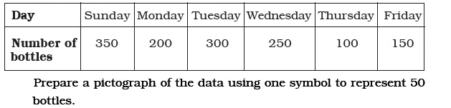

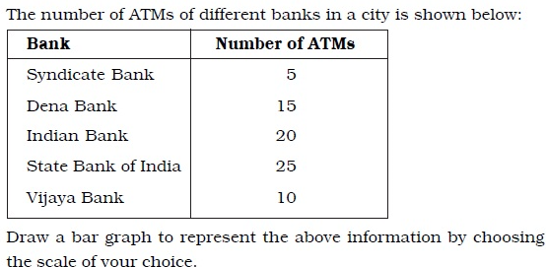

LEVEL-III
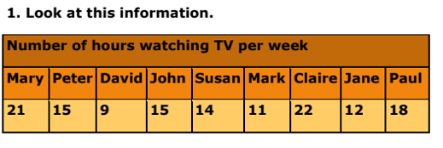
Draw the bar graph for the above data.
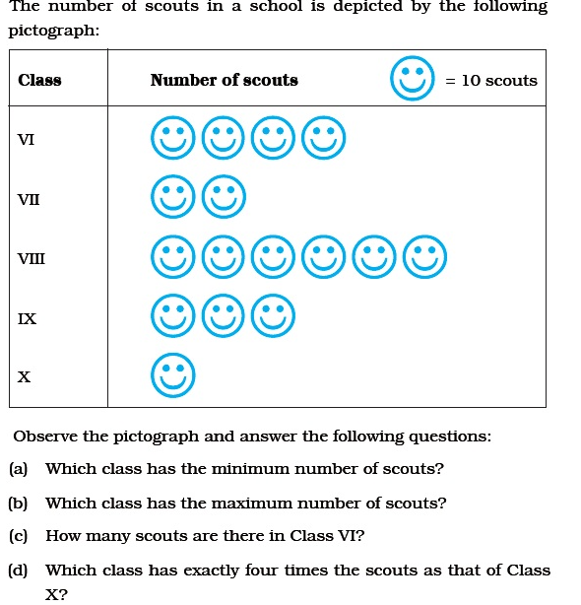
2.

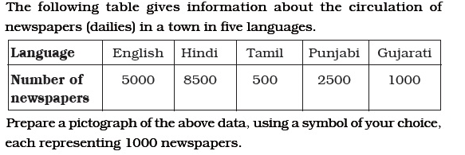
3.

Activities:
- Teacher can take collect data related to marks in PT-1, favourite subjects, games etc. and show whole process of collection, organization, representation and analysis of data.
- Students may collect data regarding colour choice of the students of their class and draw a pictograph.
- Teacher can give project to prepare bar graph for class wise enrolment
WORKSHEET
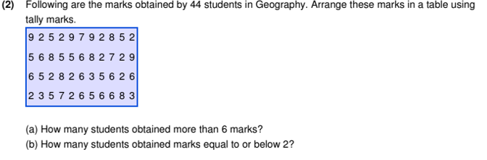
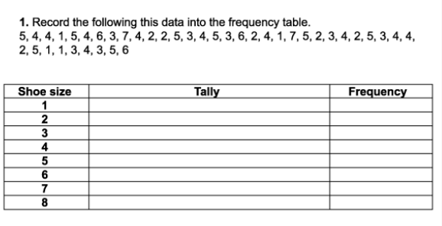

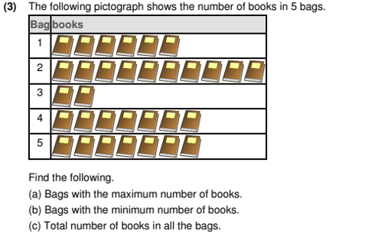

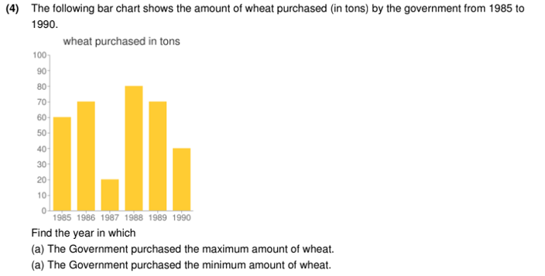

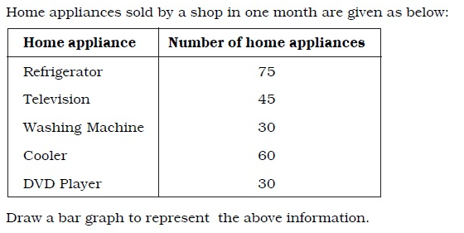
5.

*******

