MINIMUM LEVEL OF LEARNING
Chapter 10 CIRCLES
Equal chords of a circle subtend equal angles at the centre
If the angles subtended by the chords of a circle at the centre are equal, then the chords are equal
The perpendicular from the centre of a circle to a chord bisects the chord.
The line drawn through the centre of a circle to bisect a chord is perpendicular to the chord.
There is one and only one circle passing through three given non-collinear points.
Equal chords of a circle (or of congruent circles) are equidistant from the centre (or centres)
Chords equidistant from the centre of a circle are equal in length. Congruent arcs (or equal arcs) of a circle subtend equal angles at the centre
The angle subtended by an arc at the centre is double the angle subtended by it at any point on the remaining part of the circle.
Angles in the same segment of a circle are equal.
If a line segment joining two points subtends equal angles at two other points lying on the same side of the line containing the line segment, the four points lie on a circle (i.e. they are concyclic
The sum of either pair of opposite angles of a cyclic quadrilateral is 180º
If the sum of either pair of opposite angles of quadrilateral is 180$°$ then the quadrilateral is cyclic
Questions
1. Prove that equal chords subtend equal angles at the centre.
2. Prove that angle subtended by an arc at centre is twice the angle subtended by it at any point on remaining part of a circle.
3. If two equal chords of a circle intersect within the circle, prove that the segments of one chord are equal to corresponding segments of the other chord.
4. With centre O , If a line intersects two concentric circles (circles with the same centre) at A , B, C and D, prove that AB = CD .
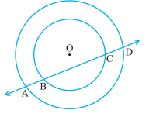
5. A, B and C are three points on a circle with centre O such that ∠ BOC = 30° and
∠ AOB = 60°. If D is a point on the circle other than the arc ABC, find ∠ADC.
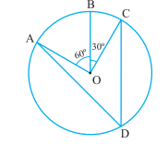
5. If the non-parallel sides of a trapezium are equal, prove that it is cyclic.

6. Prove that a cyclic parallelogram is a rectangle.

ANSWERS
5. 45⁰

