Visualising Solid Shapes

1. Recognizing 2D and 3D objects.
2. Recognizing different shapes in nested objects.
3. 3D objects have different views from different positions.
4. A map is different from a picture.
5. A map depicts the location of a particular object/place in relation to other objects/places.
6. Symbols are used to depict the different objects/places.
7. There is no reference or perspective in a map.
8. Maps involve a scale which is fixed for a particular map.
9. For any polyhedron, F + V – E = 2, where ‘F’ stands for number of faces, V stands for number of vertices and E stands for number of edges. This relationship is called Euler’s formula.
LEVEL – 1
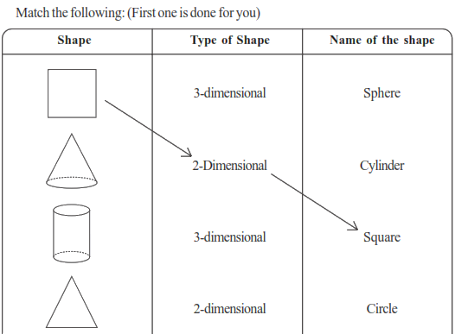
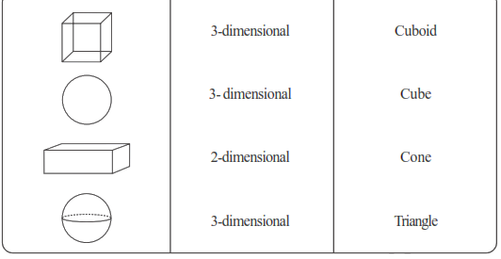

- Match the following
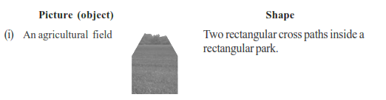

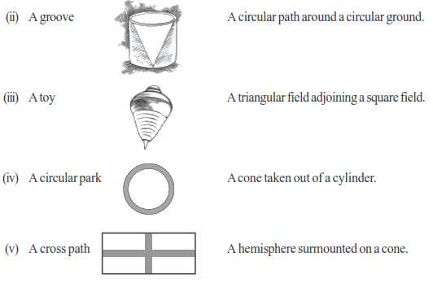

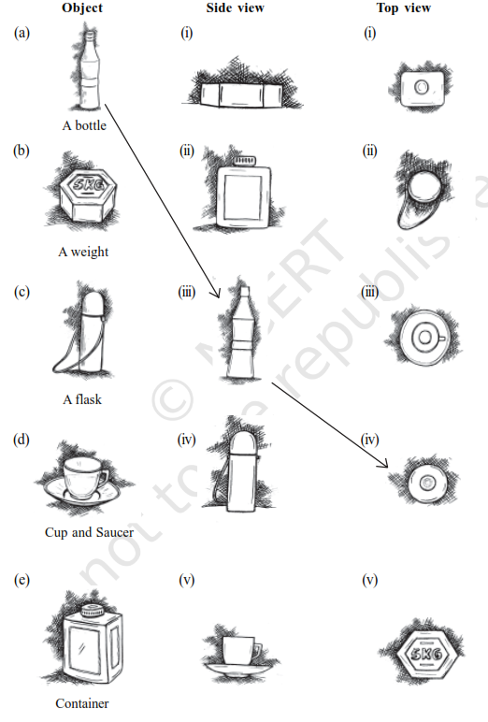
- Match the following

- For each of the given solid, the three views are given. Identify for each solid the corresponding top,
front and side views.
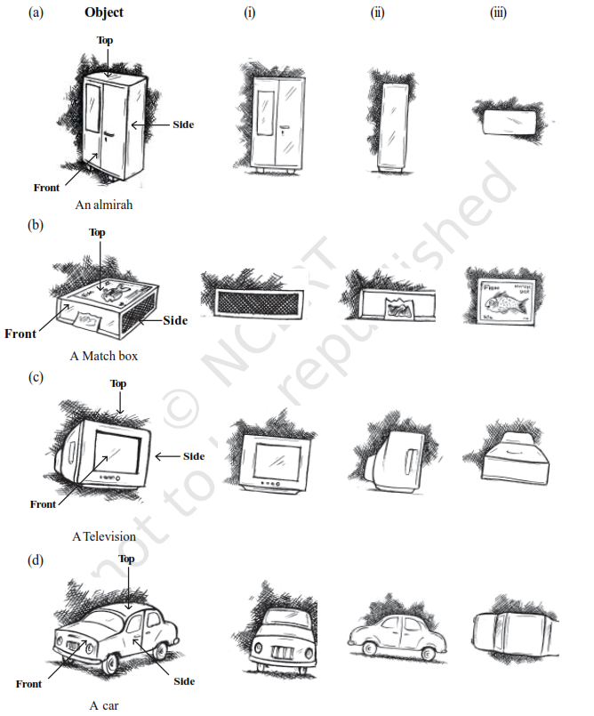

LEVEL – 2
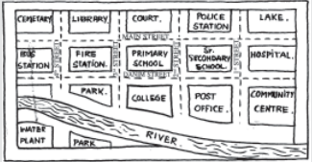
- Look at the Map

(a) Colour the map as follows: Blue-water, Red-fire station, Orange-Library, Yellow-schools, Green-
Parks, Pink-Community Centre, Purple-Hospital, Brown- Cemetery.
(b) Mark a Green ‘X’ at the intersection of 2nd street and Danim street. A Black ‘Y’ where the river meets the third street. A red ‘Z’ at the intersection of main street and 1st street.
(c) In magenta colour, draw a short street route from the college to the lake.
- Draw a map of the route from your house to your school showing important landmarks

LEVEL – 3

- Verify Euler’s formula for these solids.
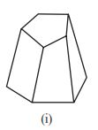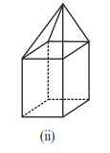
- Using Euler’s formula find the unknown.
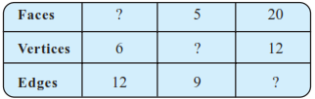
- Can a polyhedron have 10 faces, 20 edges and 15 vertices?
