MLL
3 COORDINATE GEOMETRY
KEY POINTS
1. To locate the position of an object or a point in a plane, we require two perpendicular lines. One of them is horizontal, and the other is vertical.
2. The plane is called the Cartesian, or coordinate plane and the lines are called the coordinate axes. 3. The horizontal line is called the x -axis, and the vertical line is called the y - axis.
4. The coordinate axes divide the plane into four parts called quadrants.
5. The point of intersection of the axes is called the origin.
6. The distance of a point from the y - axis is called its x-coordinate, or abscissa, and the distance of the point from the x-axis is called its y-coordinate, or ordinate.
7. If the abscissa of a point is x and the ordinate is y, then (x, y) are called the coordinates of the point.
8. The coordinates of a point on the x-axis are of the form (x, 0) and that of the point on the y-axis are (0, y).
9. The coordinates of the origin are (0, 0).
10. The coordinates of a point are of the form (+ , +) in the first quadrant, (–, +) in the second quadrant, (–, –) in the third quadrant and (+, –) in the fourth quadrant, where + denotes a positive real number and – denotes a negative real number.

1. Write the coordinates of points M, B ,S, O and L .
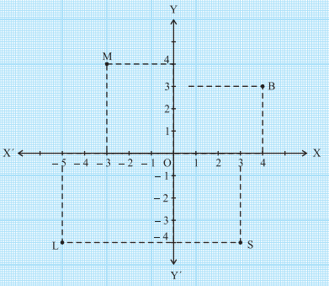
2. Write the answer of each of the following questions:
(i) What is the name of horizontal and the vertical lines drawn to determine the position of any point in the Cartesian plane?
(ii) What is the name of each part of the plane formed by these two lines?
(iii) Write the name of the point where these two lines intersect.
3. From the figure write the answer of the following:
(i) The coordinates of D.
(ii) The ordinate of C.
(iii) The point identified by the coordinates (–5, 2 ).
(iv) The point identified by the coordinates (5,-5).
(v) The abscissa of the point B.
(vi) The ordinate of the point H.
(vii) The point identified by the coordinates (0,5 ).
(viii) The coordinates of the point E .
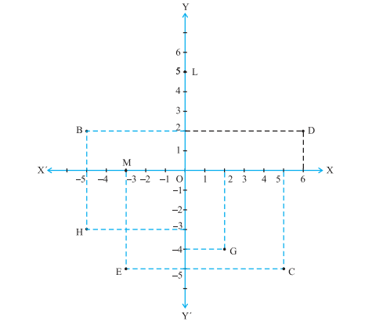
4.
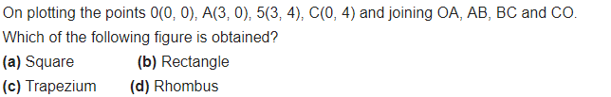
5. Plot the following ordered pairs of number (x, y) as points in the Cartesian plane. Use the scale 1cm = 1 unit on the axes. 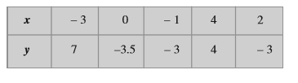

6.
7
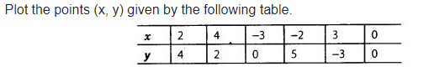
ANSWERS
- M(-3,4)
; B(4,3);
S(3,-4) ;
O(0,0) ;
L(-5,4)
- I) x-axis and y- axis
ii) quadrants
i ii) origin
- I)D(6,2) ii) -5
iii)B IV) C
v) -5 vi) -3
vii) L viii) E(-3,-5)

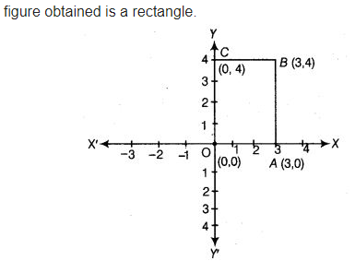
5

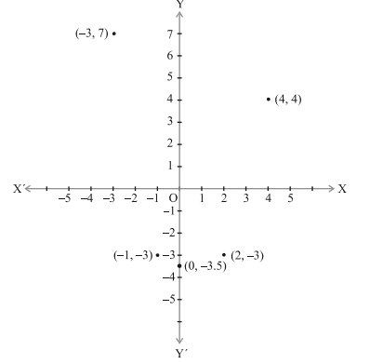

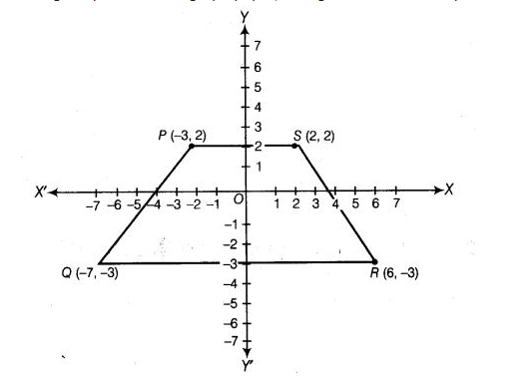
- Figure is trapezium

