Marking Scheme (Answers)
. 1- | Yes, Reason | $\frac{1}{2}$ +$\frac{1}{2}$ Mark
. 2- | $$2+\sqrt{3}$$ | 1 Mark
3- | one | 1 Mark
4 | IV | 1 Mark
5 | 0.545 | 1 Mark
6. | 1 :2 | 1 Mark
7. | Multiply by 100 and simplify  Answer 233/990 | 1Mark  1Mark
8. | Put x=-1 and substitute the value  Finding the answer -8 | 1Mark  1Mark
9. | Finding radius  To find volume | 1 Mark  1 Mark
10. | . Let the the angles be x and y  X+y=140⁰ ,x-y=20 ⁰ So, 2x=160⁰ or x=80 ⁰ And y=60⁰ | (1/2) Mark  - Mark  (1/2) Mark
11. | (i) 4/5  (ii) 1 | 1 Mark  1 Mark
12. | Drawing perpendicular on chord.  For correct proof | (1/2) Mark  (1/2) Mark
13. | Finding sides a,b,c  Finding s and Herons formula  Calculate area correctly. | 1 Mark  $\frac{1}{2}$ +$\frac{1}{2}$ Mark  1 Mark
14. | Convert in the form of a³-b³  Apply identity  Correct answer  OR  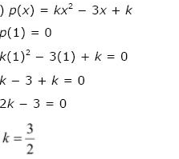 | 1 Mark  1 Mark  1 Mark  1 Mark  2 Marks
15. | Solution x= -6  Represent on number line  Represent on Cartesian plane | 1 Mark  1 Mark  1 Mark
16. | Figure  Writing Euclid’s axiom  Proving result | (1) Mark  ½ Mark  1 ½ Mark
17. | (i) Plotting the points correctly (2)  (ii) AD cuts y-axis at (0,3)  CD cuts x-axis at (-3,0) | 2 Marks  1 mark
18. | proving $∆$ABD $≅∆$ACD (BY SAS rule )  AB=AC (by CPCT) | 2 Marks  1 Mark
19. | Given, To Prove, figure  Proof | 1 ½ Mark  1 ½ Marks
20. | Given, To Prove, figure  Proof  Or  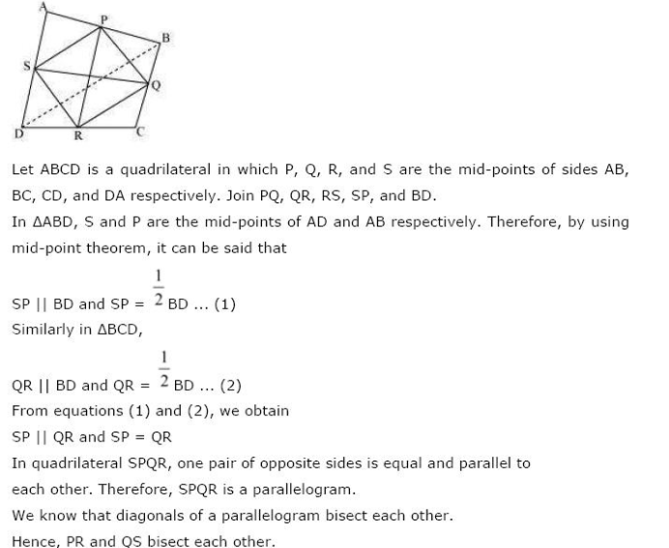 | 1 ½ Mark  1 ½ Marks  Figure:1 mark  2 marks
21. | Formula of median  X=62 | 1 Mark  2 Marks
22. | Figure  To find ∠BCD =80⁰  To find ∠ECD.= 30⁰ | 1 Mark  1 Mark  1 Mark
23. | Find radius of the cone  Find height of the cone  Apply the formula of volume and substitute the correct values  To calculate volume correctly  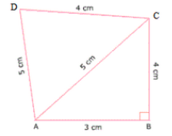  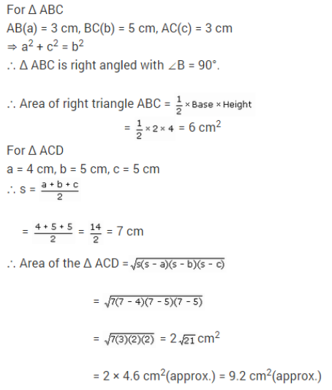 | 1 Mark  1 Mark  1Mark  1Mark  Figure:1 mark  1 mark  1 mark
24. | 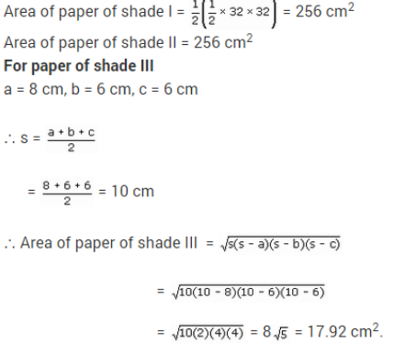 | 1 mark  ½ mark  ½ mark  ½ mark  1 ½ mark
25. | Forming an equation y=8+5(x-1)  For y= 5x+3  Finding at least two points to draw the graph on above line  Correct Graph of the line | - Mark  1Mark  1Mark  1Mark
26. | Multiply by rationalize factor  Solve above and writing the answer in the form of a+b$\sqrt{6}$  Correct values of a & b. | 1 Mark  2 Mark  $\frac{1}{2}+\frac{1}{2}$Mark
27 | To find any one factor using remainder theorem  Division process  To solve quadratic polynomial  To write all the factors correctly  OR  - To apply identity correctly  Correct answer  - To find the value of a+b+c= 0,using identity  To calculate correct answer=3abc,where a=15,b=-8,c=-7 | 1Mark  1Mark  1 Mark  1Mark  1Mark  1Mark  1 Mark  1Mark
28. | PQ || SR and QR is transversal  X+28⁰ =65⁰ (alt. int. angles)  X= 65⁰- 28⁰ =37⁰  In ∆PQS, by angle sum property of triangle  Y= 53⁰  Suitable marks for alternate methods.  OR  PR > PQ  ∠Q > ∠R ……(i)  ∠QPS= ∠RPS (given) …..(ii)  Adding 9i) and (ii)  ∠Q + ∠QPS >∠R + ∠ RPS  ∠PSR > ∠PSQ (Ext. angle prop) | - Marks  2 Marks  - mark  2 marks  1 Mark
29. | For correct construction | 4 Marks
30. | Continuous class intervals  Frequency polygon of team A  Frequency polygon of team B | 1 Mark  1 ½ mark  1 ½ mark

